**Phase 3 Final Requirements**

**Group 6**

**Tadhg O’Brien, Brandon Longworth, Austin Moody**

**User UML Diagrams**

**Actor Table:**

* **Primary actor:** The primary actor for all the use cases is the employees of Hip Hop Array.

**Use Case Diagram  
  
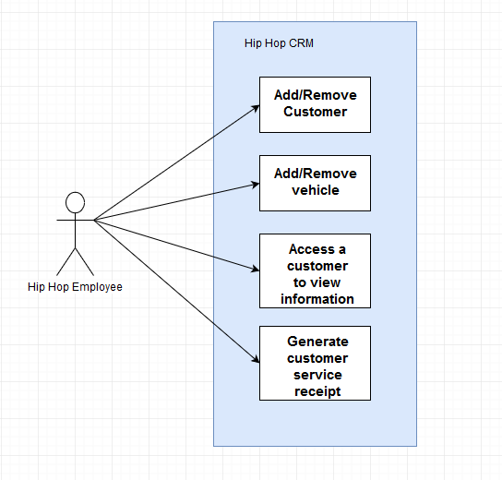  
  
  
  
  
  
Data Flow Diagram**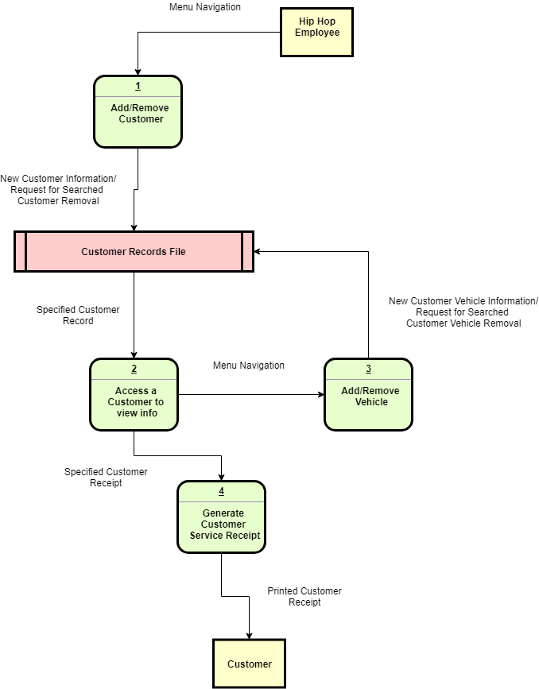

**Activity Diagram** (Zoom for clearer view) 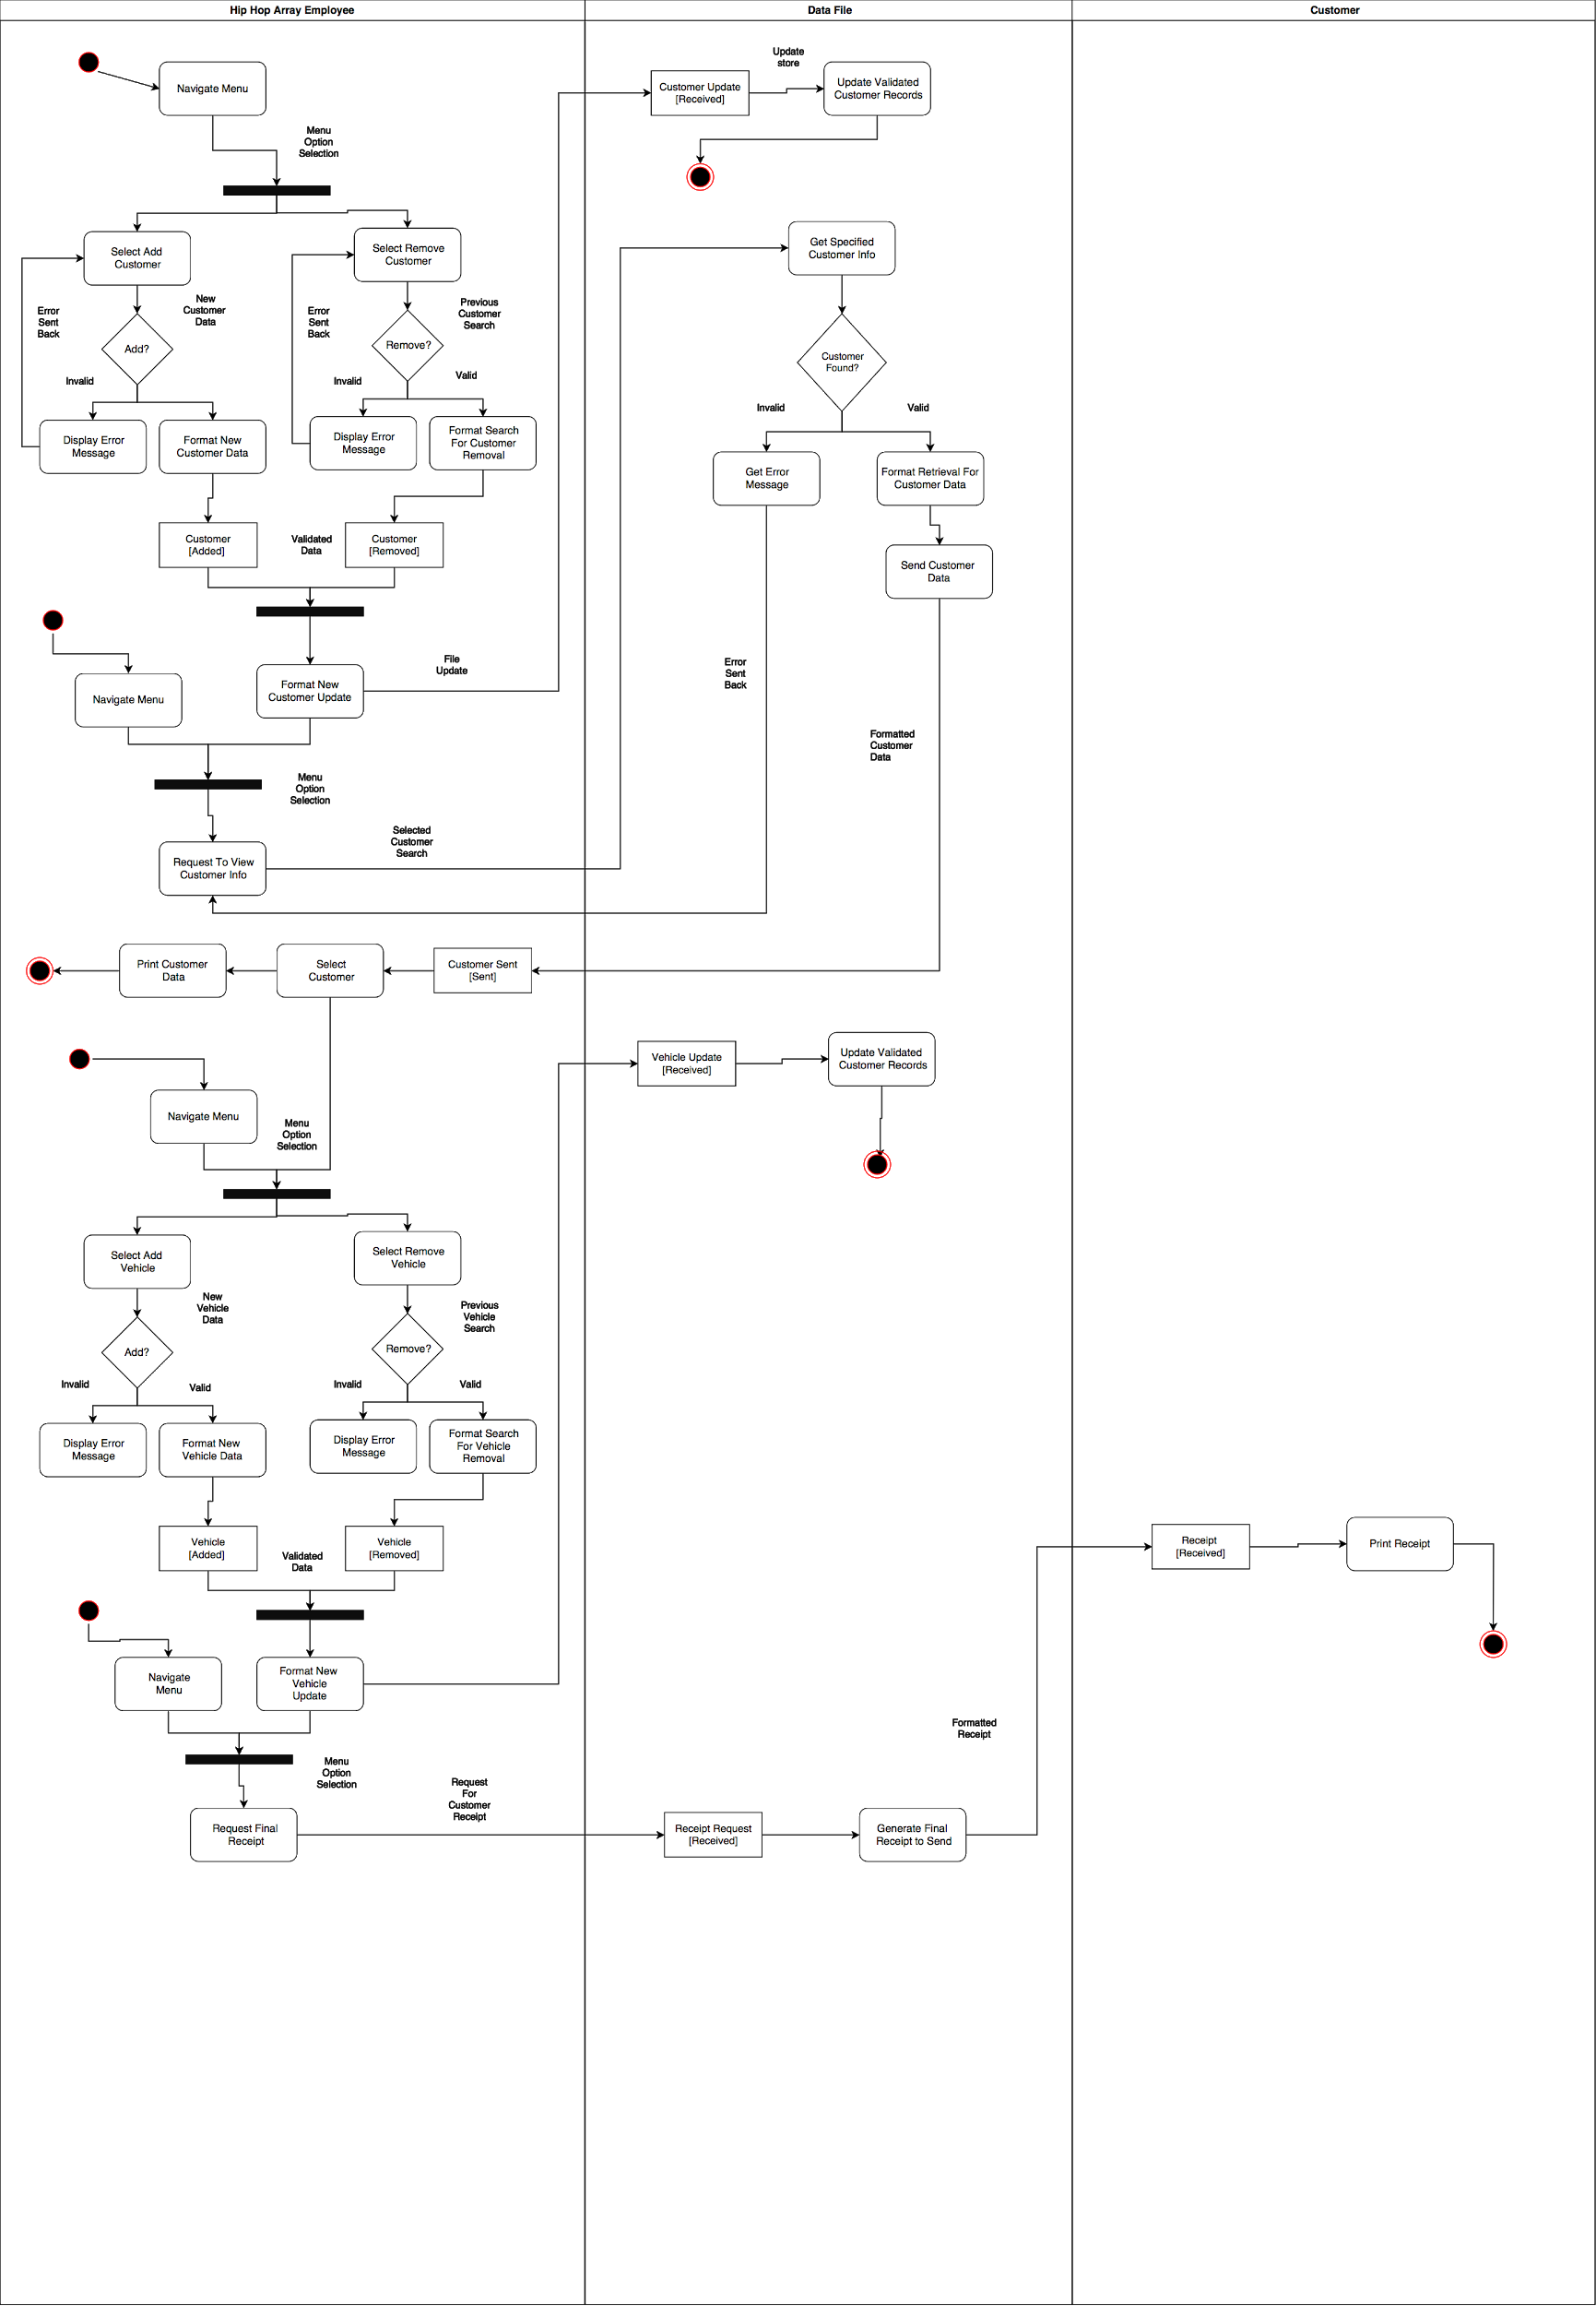

**Class Diagrams**

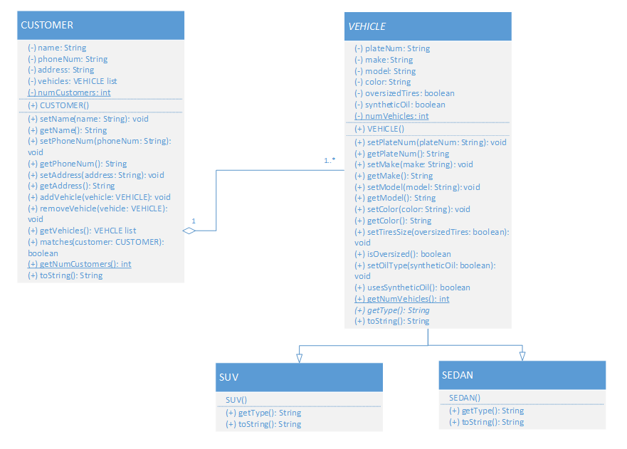

**System Implementation Activity Diagram   
  
